Which MFA Stops Phishing?
SMS, HOTP, and WebAuthn Compared

Josiah Silverberg
Course: System Security (IASP 470)
Dr. Chen
4/26/2026
Spring 2026

Acknowledgements
I would like to thank Professor Chen for his guidance and invaluable input and support during the creation of this project. I would also like to credit NIST, CISA and ArXiv for the information that helped create this comprehensive investigation and made it all possible.

Abstract
The topic of authentication is widely discussed in cybersecurity, particularly in terms of ensuring that authentication mechanisms remain secure against adversarial attacks. The most common method, the username and password combination, is well known for its weaknesses and susceptibility to attacks such as phishing and dictionary attacks. To address these shortcomings, multi-factor authentication (MFA) was introduced, adding an additional layer of verification to improve security. However, not all MFA methods provide the same level of protection.
This research evaluates three authentication methods: SMS-based one-time passwords (SMS OTP), HMAC-based one-time passwords (HOTP), and WebAuthn. Each method is tested for its ability to resist phishing and adversary-in-the-middle attacks that attempt to compromise user credentials. To conduct this experiment, a web-based ticketing system with MFA-enabled login was developed alongside a phishing site designed to mimic the legitimate system and capture user input. The success rate of phishing attacks was then measured for each authentication method.
The results show that both SMS OTP and HOTP are vulnerable to phishing attacks, while WebAuthn demonstrates strong resistance due to its underlying security design.

Table of Contents
Acknowledgements 2
Abstract 3
Background 5
1.1 OTP vs Origin Binding 5
1.2 Evaluation Plan 6
1.3 Study Goal 6
Introduction 10
How They Function 11
2.1 SMS-OTP 11
2.2 HMAC-OTP 13
2.3 WebAuthn 14
Methodology 16
3.1 Criteria 16
3.2 Specific Goals 17
3.3 Research Gap 18
Implementation 19
4.1 Web App Exploitation 19
4.2 Initial Trials 30
Results/Discussion 31
5.1 Experiment Findings 31
5.2 Result Interpretations 32
5.3 Limitations 33
Conclusion 33
References 36

Background
In modern digital systems, authentication serves as the first and most critical defense against unauthorized access. As organizations increasingly rely on web-based platforms for sensitive operations, the security of authentication protocols has become a central concern in cybersecurity. Multi-factor authentication (MFA) has been widely adopted as a solution intended to strengthen authentication by requiring additional verification factors beyond passwords. However, recent security incidents demonstrate that many MFA mechanisms remain vulnerable to advanced phishing and adversary-in-the-middle (AiTM) attacks.

1.1 OTP vs Origin Binding
One particularly vulnerable category of MFA is one-time password (OTP) authentication. Systems such as SMS-based OTP and time-based or HMAC-based authenticators rely on shared secrets and temporary codes that users manually enter during login. Modern phishing frameworks are capable of intercepting these codes in real time through proxy-based attacks. In these scenarios, attackers position themselves between the victim and the legitimate service, harvesting both credentials and MFA tokens before forwarding them to the real site to gain authenticated sessions.
These weaknesses have motivated the development of phishing-resistant authentication standards such as WebAuthn, which is part of the FIDO2 framework. Unlike OTP systems, WebAuthn relies on asymmetric cryptography and origin binding, meaning authentication responses are cryptographically tied to the legitimate domain. This architectural difference significantly changes how authentication credentials are generated and verified.
Understanding how these authentication mechanisms perform against modern phishing techniques is important for both theoretical and practical reasons. From a theoretical perspective, analyzing their cryptographic structures helps explain why certain authentication models are more resistant to adversarial manipulation. From a practical perspective, organizations must determine whether legacy MFA implementations remain sufficient or whether migration to phishing-resistant authentication standards is necessary. This research aims to analyze the structural and operational differences between SMS OTP, HOTP authenticators, and WebAuthn to determine which provides the strongest protection against contemporary phishing attacks.

1.2 Evaluation Plan
The authentication protocols will be evaluated using several security criteria:
• Phishing resistance – whether the protocol can prevent credential harvesting via phishing websites
• Adversary-in-the-middle resistance – whether authentication tokens can be intercepted and reused
• Credential replay resistance – whether captured authentication data can be reused in future sessions
• Protocol architecture – shared secret vs asymmetric cryptography
• Origin binding – whether authentication responses are bound to the legitimate domain
Each authentication system will be compared using these criteria to determine which offers the strongest defense against modern phishing frameworks.

1.3 Study Goal
This research aims to contribute a clearer comparative understanding of the security differences between legacy OTP-based MFA systems and modern phishing-resistant authentication standards.
Specifically, the study will:
• Provide a structured comparison of SMS OTP, HOTP, and WebAuthn authentication mechanisms
• Identify the architectural features that make certain authentication systems more resistant to phishing attacks
• Evaluate whether modern phishing frameworks undermine the security assumptions of traditional MFA
• Provide practical insights that may help organizations choose stronger authentication methods
The research consistently identifies one-time password (OTP) systems (particularly SMS-based OTP and HOTP) as relatively weak forms of authentication. According to IDManagement.gov, OMB Memorandum M-22-09 mandates that federal agencies adopt phishing-resistant authentication methods and phase out weaker alternatives. SMS-based OTP is explicitly identified as insecure, with HOTP considered similarly vulnerable due to its reliance on shared secrets.
Guidance from Cybersecurity and Infrastructure Security Agency reinforces this position. CISA identifies WebAuthn as a phishing-resistant authentication method, emphasizing that it is not susceptible to common attack vectors such as SIM swapping, SS7 exploitation, or push-based social engineering attacks. In contrast, CISA notes that traditional OTP mechanisms - including HOTP - remain vulnerable to phishing and adversary-in-the-middle attacks, while SMS-based OTP is exposed to an even broader range of threats due to weaknesses in telecommunications infrastructure.
Collectively, these findings support a clear security hierarchy: SMS-based OTP represents the weakest authentication method, HOTP offers marginal improvement but remains vulnerable, and WebAuthn provides significantly stronger protection due to its cryptographic design and resistance to credential interception. This aligns with broader industry conclusions that prioritize phishing-resistant, origin-bound authentication mechanisms over shared-secret approaches (Provos 2023).
Through testing, these were some charts that were created based on their designs. For the OTP models, this is their logic flow:
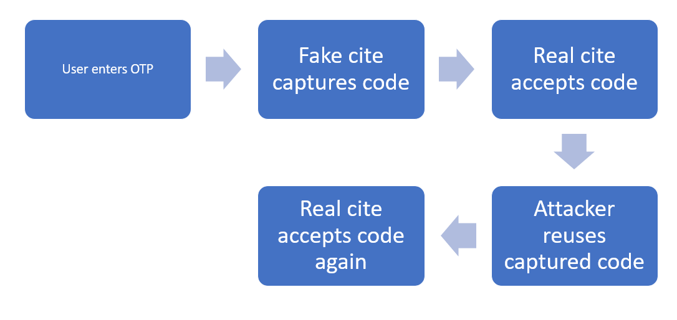
Figure 1: SMS-OTPs flow chart
The issue with these is that if the code is intercepted by an adversary in the middle, the code can then be used afterwards if it is not reset by the user. This means that phishing is a highly effective way to breach this authentication method, with them being insufficient to handle such attacks.
With the SMS code particularly, it is not only vulnerable to phishing. They are also weak to SS7 channel exploitation, where the transmission portion of the data can be compromised. SIM swapping is also an effective method against the SMS codes, as the code will be sent to a different device altogether, being a major risk in the security of this authentication method (Authenticator and Verifier Requirements 2025).
For WebAuthn, it utilizes a method called origin/name binding to create additional security. It generates an authorization secret based on the unique domain name of the verifier. This means that a user will have a unique passkey with every domain, and if it is attempted to be used on a fake website, it will not match and be denied. For example, when a user attempts to log into bank.com using a passkey, the authentication succeeds because the cryptographic credentials are bound to that legitimate domain. However, if an attacker sends a phishing link to a fake site such as fbank.com, the authentication attempt will fail. This is because passkeys are tied to the original domain, and the browser or authenticator will not release or use the credential for a different origin. As a result, authentication relies on multiple layers of security: possession of the correct cryptographic key and verification of the legitimate domain. If either condition is not met, the login attempt is automatically denied. (Implementing phishing-resistant MFA 2022)
This would be an accurate flow of WebAuthn:

Figure 2 – Webauthn’s Flowchart

Introduction
Passwords have long served as the primary mechanism for user authentication; however, they have been inherently limited since their inception. Early systems operated in an environment with constrained computational resources, masking many of these weaknesses. As a result, defenses such as computationally expensive hashing algorithms were initially sufficient to deter brute-force and dictionary attacks. Today, however, advances in computing power have significantly eroded these protections, enabling attackers to crack short passwords within minutes using widely available hardware (Provos 2023; Center for Information Technology 2023).
While longer passwords improve security, they introduce usability challenges, leading many users to adopt weak or reused credentials. This creates a cascading risk, where a single data breach can compromise multiple accounts. In response, modern authentication systems have incorporated multi-factor authentication (MFA) to strengthen security beyond static passwords.
Among these methods, SMS-based authentication uses randomly generated one-time passwords (OTPs) created server-side and tied to a specific login attempt. HOTP (HMAC-based One-Time Password) relies on a shared secret key between the server and client device to generate matching codes. Although these approaches enhance security, they still depend on transferable codes or shared secrets that can be intercepted or replayed in phishing scenarios.
To address these limitations, WebAuthn introduces a passwordless authentication model based on asymmetric cryptography and enforced through the browser’s security model. By leveraging public-private key pairs and binding authentication to the legitimate web origin, WebAuthn significantly reduces susceptibility to credential interception.
Given these differences, this study investigates the following research question:
How do SMS, HOTP, and WebAuthn differ in their resistance to phishing and adversary-in-the-middle attacks under modern web threat models?

How They Function

2.1 SMS-OTP
SMS codes are randomly generated one-time passwords (OTPs) created server-side and associated with a specific login attempt at a given time. The code is delivered through a telecommunications provider via the SS7 (Signaling System No. 7) infrastructure to the recipient’s mobile device. The user then enters this code into the application or website they are attempting to access, and the server either accepts or rejects the input.
SMS-based OTPs function as a possession factor (something the user has: their phone number/SIM), but they do not rely on cryptographic verification of the delivery channel itself. For this method to be secure, several conditions must be met:
- The SIM card must remain in the possession of the legitimate user.
- The telecommunications provider must not be compromised.
- The SS7 infrastructure must not be exploited.
- The user must not be socially engineered.
- The device must not be stolen or infected with malware.
- The OTP must not be intercepted in real time.
Although these conditions are met in the majority of cases, there are notable exceptions that raise security concerns.
The first major attack vector is SIM swapping. In this attack, a threat actor contacts the telecommunications provider and claims that their device has been lost or stolen. By providing personally identifiable information (PII) - often obtained through data breaches or open-source intelligence (OSINT) such as the victim’s social media - the attacker convinces the provider to transfer the victim’s phone number to a new SIM card under their control. Once successful, all SMS-based OTPs are delivered to the attacker’s device, enabling them to compromise accounts associated with that phone number. Because phone numbers are not cryptographically bound to a specific device and can be reassigned, the telecommunications provider becomes a critical point of failure that must be highly secured.
Another significant vulnerability involves SS7 exploitation. SS7 is the signaling protocol used by telecom providers to route SMS messages, manage roaming, and handle call setup. The protocol was designed decades ago under the assumption of mutual trust between participating carriers. As a result, it lacks strong authentication mechanisms. Attackers who gain access to SS7 networks can redirect SMS messages, intercept OTPs, or track subscriber activity. This places the security of SMS-based authentication outside the control of the end user and instead within the broader telecommunications infrastructure. For organizations requiring high assurance authentication, this dependency may be unacceptable.
Device compromise is another concern. If spyware or malware is installed on a user’s device - often through trojans disguised as legitimate applications - it may monitor incoming SMS messages and capture OTPs in real time. An attacker can then reuse the intercepted code before it expires. This risk highlights the importance of user vigilance and endpoint security.

2.2 HMAC-OTP
HMAC-based One-Time Password (HOTP) operates differently. It establishes a shared secret key (K) between the server and the client device. This secret is stored securely on both sides. The client also maintains a counter value (C). When authentication is required, the client computes:
HOTP = Truncate (HMAC-SHA-1(K, C))
The resulting numeric code is presented to the user, who enters it into the authentication interface. The server independently performs the same calculation using its stored copy of K and C. If the results match, authentication succeeds.
This method is deterministic: given the same key and counter value, both sides will generate the same OTP. It is therefore symmetric in nature. Unlike SMS-based OTPs, HOTP does not require a delivery channel, as the code is generated locally on the device.
One major advantage of HOTP over SMS is that it does not rely on telecommunications networks. This eliminates SS7-based interception risks and removes dependency on SIM cards, making it resistant to SIM swapping. Additionally, HOTP codes are generated through cryptographic computation rather than random server-side generation transmitted over a network.
However, HOTP has its own limitations. Because it relies on a shared secret, the system’s security depends on the protection of that key. If an attacker gains access to the server database through a breach, they may extract users’ secret keys. With possession of a secret key, an attacker can generate valid OTPs indefinitely. In large-scale breaches, compromise of many stored secrets could enable widespread account takeover. This makes secure storage (e.g. hardware security modules and strong encryption practices) critical.
HOTP is also vulnerable to phishing. Since the OTP is valid at the moment it is generated, an attacker who tricks a victim into entering credentials and their HOTP code on a malicious website can immediately reuse that code on the legitimate site before it expires or before the counter increments. HOTP verifies only that the correct code was provided - it does not verify the origin of the request.
Perhaps the most significant limitation of HOTP is that it lacks built-in origin binding. It cannot verify domain names, TLS certificates, or whether the authentication request originated from a legitimate website. It simply checks whether the code matches. Modern authentication standards such as WebAuthn incorporate origin verification: if the domain does not match the expected trusted origin, authentication is rejected. This provides protection against phishing by ensuring both the code and the requesting party are legitimate - something HOTP alone cannot guarantee.

2.3 WebAuthn
WebAuthn is a passwordless authentication standard built on asymmetric cryptography and enforced through the browser’s security model. During credential registration, the client generates a unique public–private key pair tied to the relying party’s origin. The private key remains securely stored on the user’s device and is non-exportable, while the public key is registered with the authentication server. During authentication, the authenticator signs a server-issued challenge that includes origin information derived from the TLS session. Because this signature is cryptographically bound to the legitimate domain, authentication attempts originating from phishing sites will fail.
A key strength of WebAuthn is its use of origin-bound credentials. Each domain receives a unique key pair, meaning credentials are not reused across services. This eliminates one of the primary weaknesses of traditional authentication systems, where shared secrets can be intercepted or reused. As a result, phishing attacks (particularly adversary-in-the-middle attacks that succeed against SMS-OTP and HOTP) are largely ineffective, since a fraudulent domain cannot produce a valid signature for the legitimate relying party.
WebAuthn also improves security through its use of asymmetric cryptography. Unlike shared-secret systems, the server stores only the user’s public key, while the private key never leaves the user’s device. Even in the event of a server-side data breach, attackers cannot obtain usable authentication credentials. This design significantly reduces the risk of credential theft, replay attacks, and unauthorized account access.
Additionally, WebAuthn provides implicit protection against credential reuse attacks. Because each site has a distinct key pair, a compromise of one service does not expose credentials for any other. This effectively provides the security benefits of strong, unique passwords for every account without the associated usability challenges.
Despite these advantages, WebAuthn introduces several practical challenges. One limitation is implementation complexity. The protocol requires HTTPS and strict origin configuration, as authentication is tightly bound to verified domains and relying party identifiers. Organizations must also implement WebAuthn APIs and correctly manage credential registration, challenge generation, and signature verification. Compared to simpler mechanisms such as SMS-based OTP, this increases deployment overhead and may discourage adoption in environments constrained by legacy systems or limited resources.
Device dependency is another consideration. Because private keys are stored on user devices, loss of access to the device can result in account lockout unless robust recovery mechanisms are in place. This necessitates additional backup authentication methods, which can introduce complexity and potential secondary vulnerabilities if not carefully implemented.
Compatibility also remains a limitation. While most modern browsers and devices support WebAuthn, older systems may not, making universal deployment across all users and environments difficult without infrastructure upgrades.
Finally, WebAuthn shifts the primary attack surface from the network to the endpoint. Since credentials cannot be intercepted in transit, attackers are more likely to target the user’s device directly. A full device compromise could allow an attacker to leverage the private key for authentication. Although this risk exists for all authentication systems, it highlights the importance of endpoint security measures such as device hardening, secure enclaves, and user awareness.

Methodology

3.1 Criteria
The methodology for this study involves analyzing and evaluating three passwordless authentication protocols - SMS-OTP, HOTP, and WebAuthn - based on their resistance to phishing and adversary-in-the-middle attacks. Each protocol will be examined in terms of its structure, practical use cases, and inherent strengths and weaknesses.
Evaluation will occur in two phases. First, a theoretical analysis will be conducted, focusing on the design and underlying architecture of each protocol. A literature review will be used to understand how each method was developed, how it operates, and the contexts in which it is commonly implemented (All done above). These findings will then be interpreted in relation to known phishing and man-in-the-middle attack techniques to assess each protocol’s expected resilience.
Second, an empirical evaluation will be performed through controlled experiments simulating real-world phishing scenarios. Each authentication method will be tested against a phishing environment designed to mimic a legitimate login system. The success rate of attacks will be measured under varying conditions (e.g. immediate use, delayed response), providing insight into how each protocol performs in practice.
Following both analyses, the protocols will be compared and ranked based on their effectiveness against each attack type. Performance will be evaluated across multiple categories, including susceptibility to credential interception, resistance to replay or relay attacks, and overall security reliability.
Notably, WebAuthn differs fundamentally from the other methods. It allows users to authenticate using a device-based credential (such as biometrics or a hardware key) instead of a password, and authentication is cryptographically bound to the legitimate website’s domain. As a result, phishing attempts fail automatically, since fraudulent sites cannot produce valid authentication responses.

3.2 Specific Goals
- Compared attack success rates between the models: percentage of login attempts where attacker successfully gains access by running simulated phishing/AiTM attempts (Success Rate = (Successful Attacks/Total Attempts) x 100)
- Compare the feasibility of Replay attacks: analyze whether capture credentials in an AiTM attack can be subsequently reused by an attacker
  - Can OTP be reused within a certain amount of time (validity window)?
  - Can the session be hijacked?
    - Either yes or no. If yes, the % of successful replay attacks will be compared
- Origin Binding Effectiveness – If authentication is tied to one real domain only
  - Does Authentication work on a phishing (fake) domain?

3.3 Research Gap
Most research on this topic is done at the theoretical level, which focuses on general usability and security. One study records that less than 14% of all phishing related papers cover any active hands on studies that involve interviews, surveys or lab practices (Das et al., 2019). Lack of practical, real-world frameworks that will evaluate how modern phishing kits attempts to bypass MFA, which is what this research hopes to achieve.

Implementation

4.1 Web App Exploitation
To conduct the research, a login page was created for an incident reporter application. A user would be asked to input their credentials for access to the admin panel.
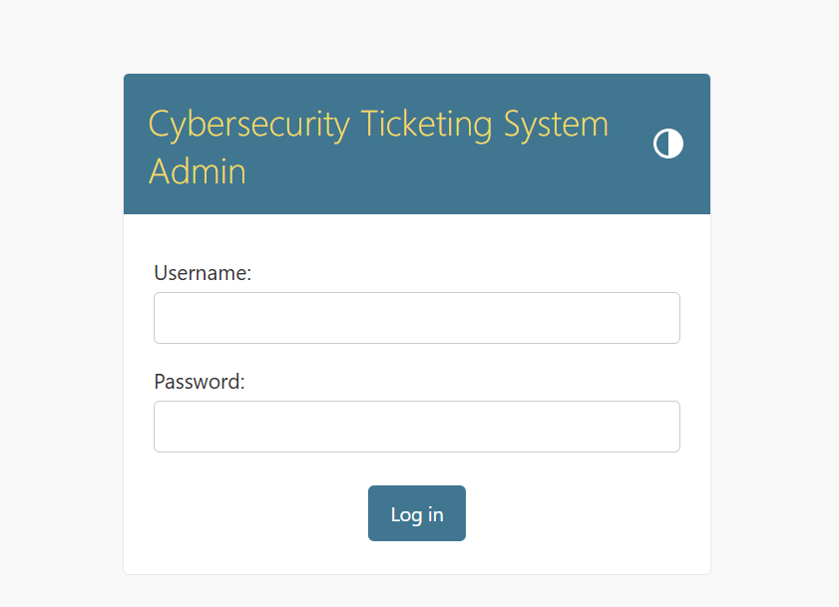
Figure 3—Web App Login Screen
Once the credentials are entered, the user may then view the various tickets and manage them.
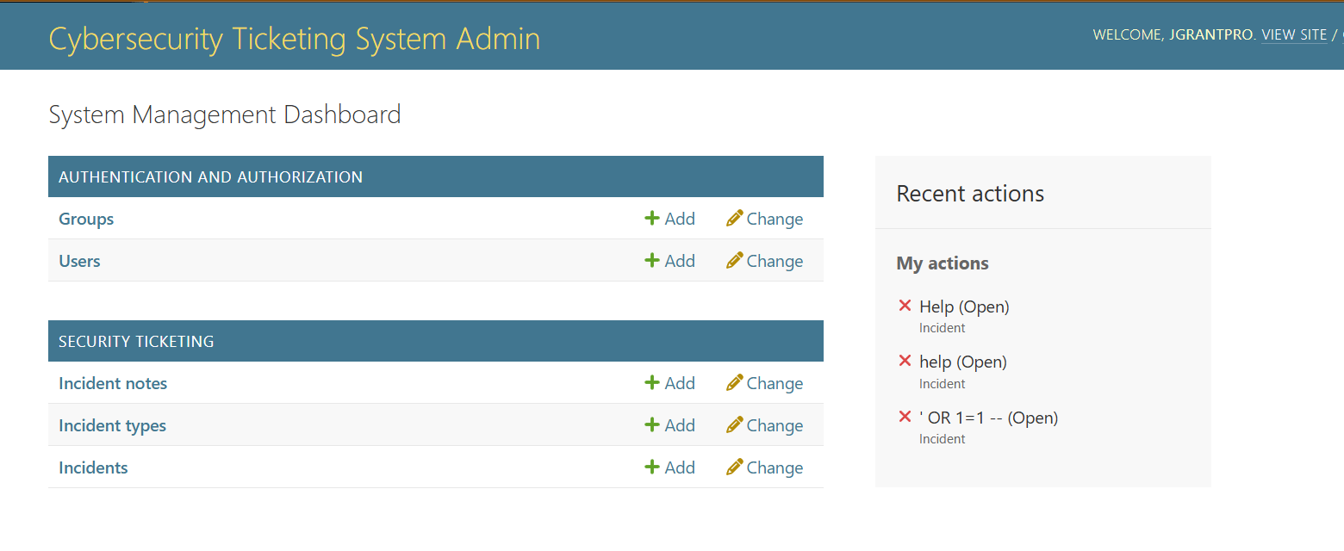
Figure 4—Admin Dashboard after successful login
For the purposes of this research, an OTP model was employed to request the OTP (sent via terminal) after the correct username and password were entered.
An example of a user entering their credentials on the website:
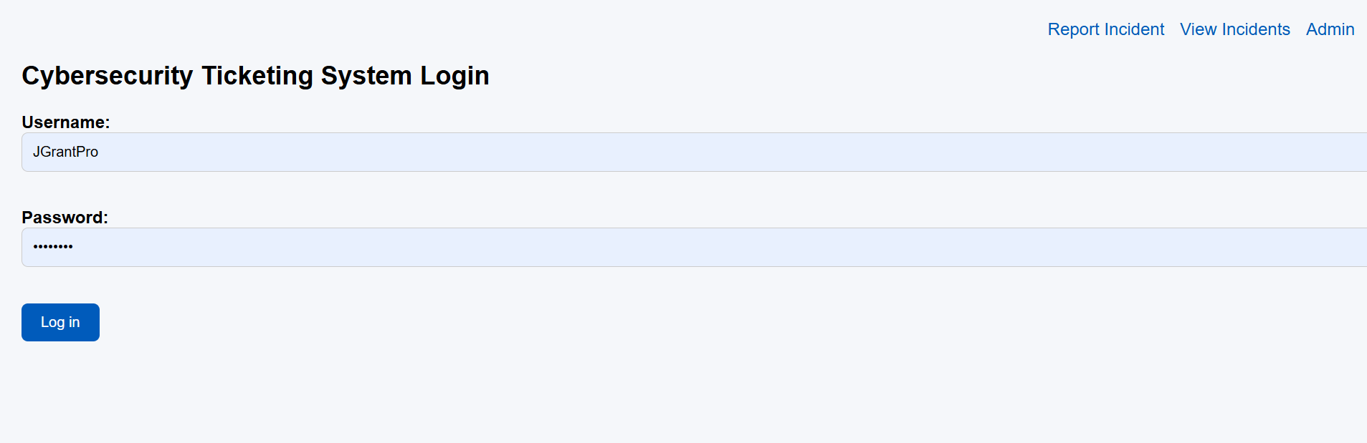
Figure 5—SMS-OTP username/password login
If incorrect, it will be rejected before the OTP phase.
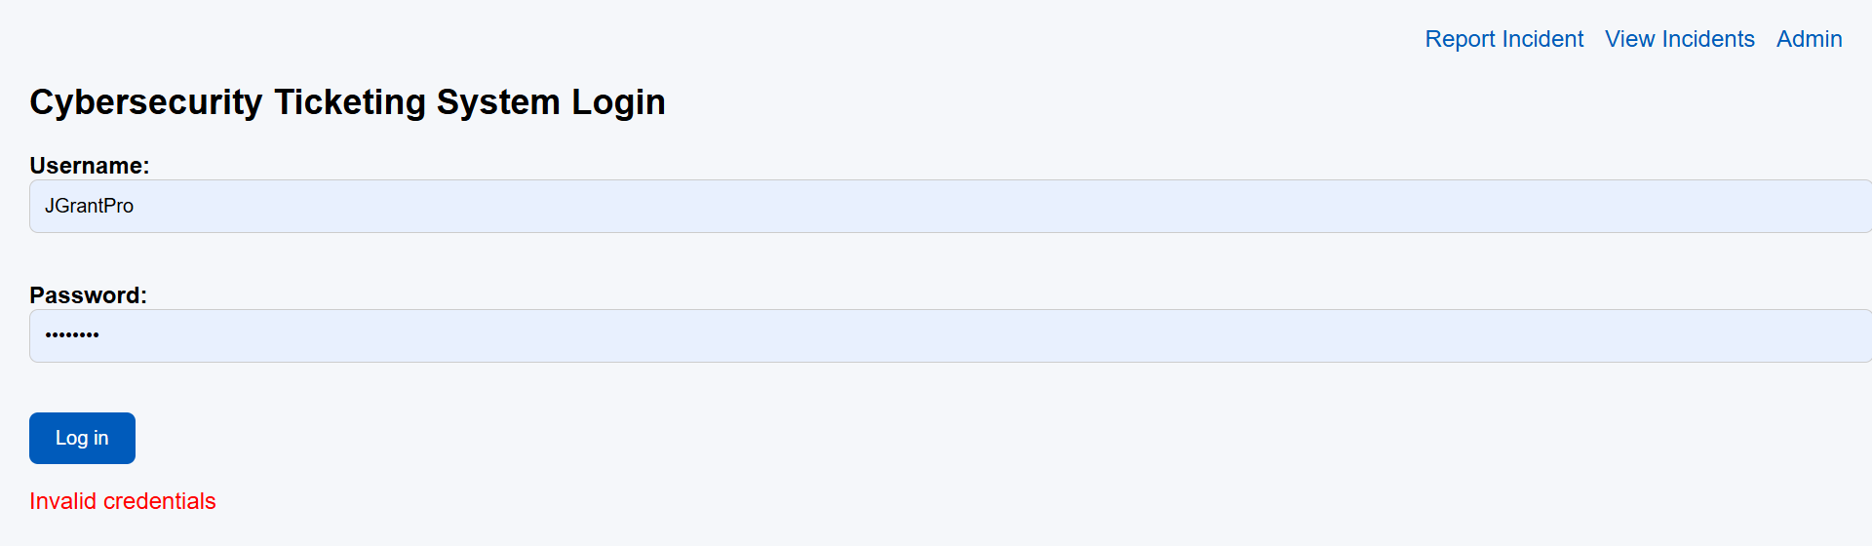
Figure 6—Failed SMS-OTP username/password entry
If correct, they will be asked to enter their OTP. A terminal message will be used to represent the SMS/HMAC OTP.
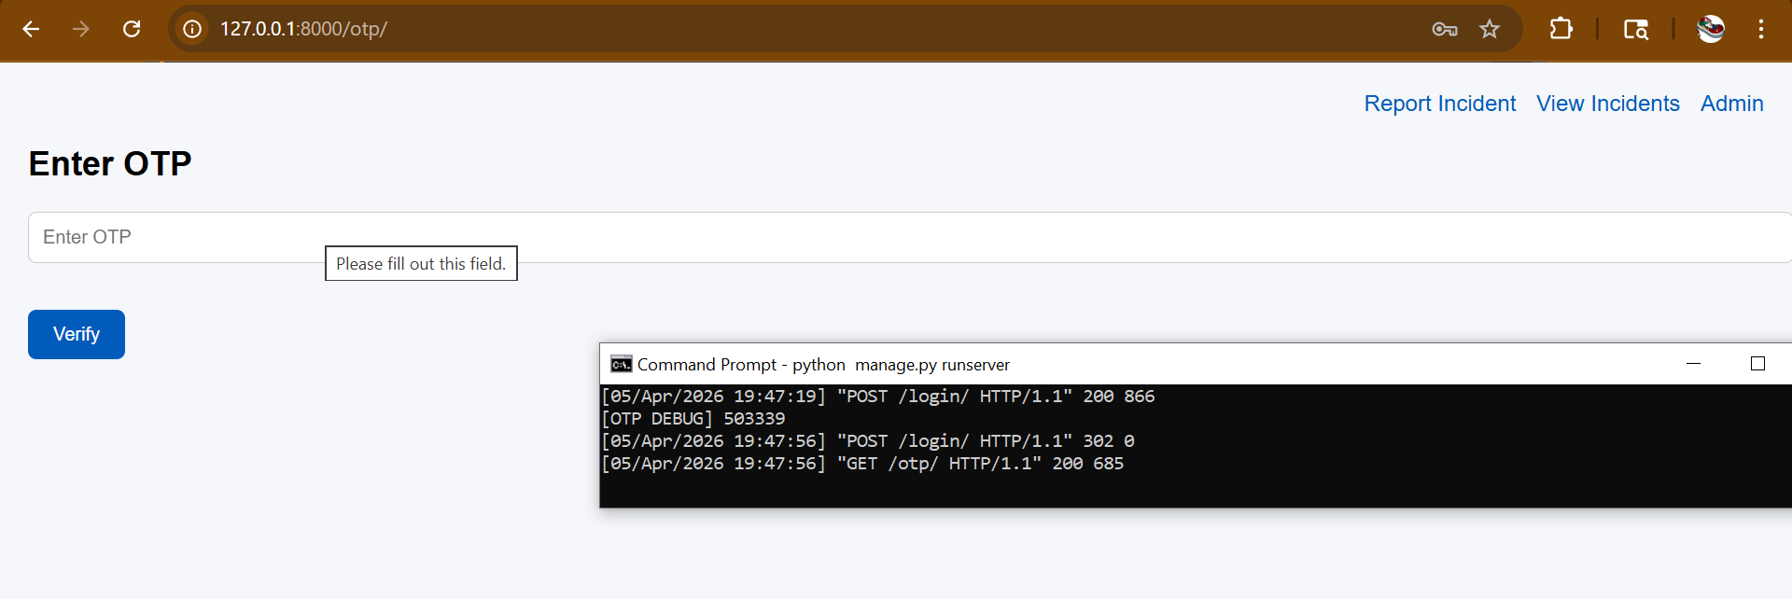
Figure 7—SMS-OTP one-time code screen, with code given
If entered, they will be allowed into the account.
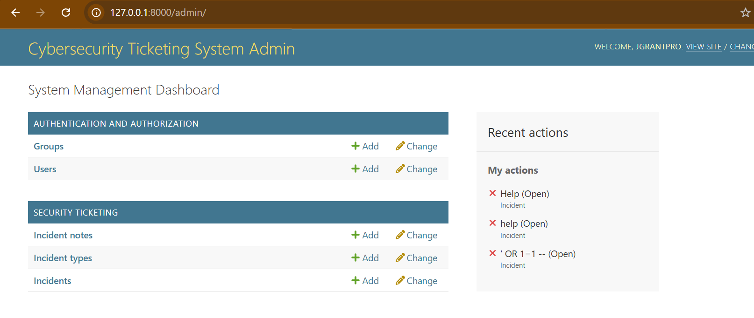
Figure 8—SMS-OTP admin dashboard panel
Now a fake phishing site designed to impersonate the original will be used to simulate an attack.
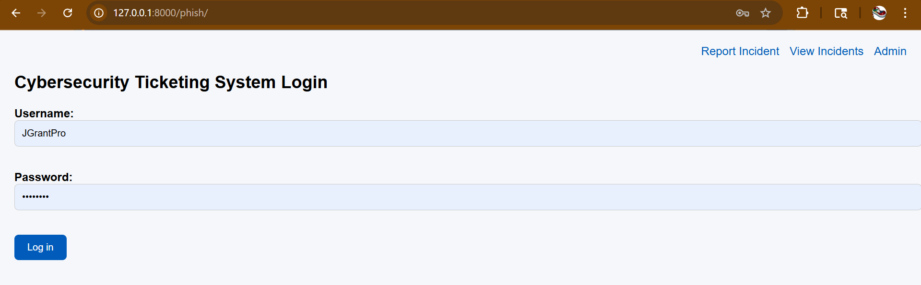
Figure 9—Fake Phishing SMS-OTP login screen
Once the username and password are entered, the user is prompted to enter their OTP.
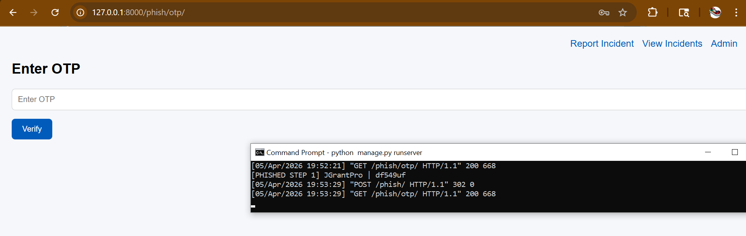
Figure 10—Phishing OTP one-time code screen
Because the site is fake and cannot generate an OTP, the attacker can either use a script or manually used the phished credentials quickly on the real site to create a OTP that the user will also enter. Once done, the attacker can use this OTP the compromise the account.
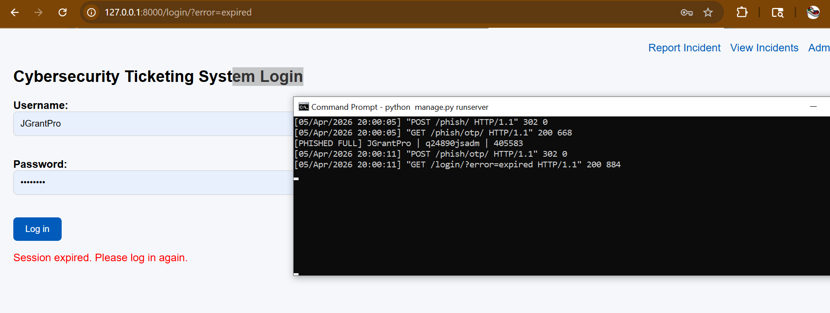
Figure 11—User redirected to real site after adversary captures credentials and one-time code
This gives the attacker everything they need to compromise the account. To cover their tracks, they can redirect the user to an error screen on the real website to act as if it was a system error, so the user does not suspect anything.
There will be a phishing login screen employed designed to mimic the authentic one, as well as an authentication screen that redirects to the original site.
To start, these attacks were run immediately once the credentials was entered into the phishing site with 0 seconds of delay 10 times. All attempts were successful.
Then the attacks were run at a 30 second and 60 second delay. For 30 seconds, the results were 70% success. This may be because the delay in the OTP arriving caused them to either refresh or search the URL themselves, bringing them to the real site and avoiding the attack.
For 60 seconds, the attack success was near 0 due to 1. The previous user frustration chance and 2. The token expiring, resulting in it being meaningless.
The results from this experiment seem to tell that SMS-OTP can provide limited protection if accompanied by a time-based OTP from delayed attacks but are much weaker the quicker the attack is conducted.
These findings indicate that the effectiveness of SMS OTP is primarily dependent on timing constraints rather than inherent resistance to phishing. Attackers who operate within the OTP validity window can reliably bypass this form of multi-factor authentication.
Time Before Attack | Approximate success rate
0 Seconds (instant) | 100%
30 Seconds | ~70%
60 Seconds | ~0% (Code expires)
Figure 12—Chart recording first 10 phishing attempts on SMS-OTP based login

Unlike SMS-based OTP, HOTP does not rely on time-based expiration but instead uses a counter-based mechanism. Experimental results showed that HOTP codes remained valid regardless of delay, resulting in a 100% success rate even when the attacker delayed execution. While this removes timing-based failure conditions, it does not mitigate phishing attacks, as attackers can still capture and replay the code.
For HOTP, the same OTP process stayed the same, but the code would only expire after it gets reissued. Since it is not time based, the success of the attack has less to do with time directly. This means there is no set amount of time when the phish will automatically fail, unlike the SMS-OTP, which was time based. The way this can fail, however, is if the attacker stalls for too long, allowing the user to get impatient or suspicious, causing them to reestablish the connection, such as by typing the URL of the real website and re-entered their credentials. This means that even if the attacker got the old HOTP, it would be useless by the time they tried to use it later.
For Webauthn, cryptographic keys will be assigned for both the server (public) and user (private).
Firstly, the user registers their device with the website.
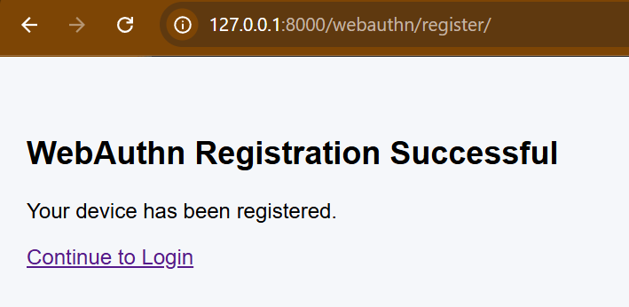
Figure 13—WebAuthn registration screen for web app
This creates the public (server) and private (device) key.
After, the user can authentication via the web browser authenticator.
(If no credentials are available for the device, the authenticator will give an error)
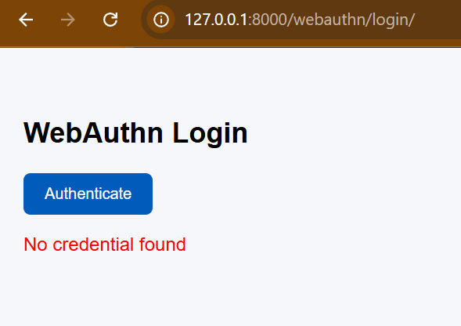
Figure 14—Failed authentication on WebAuthn login due to no credentials
If the signature matches using the correct private key, the user will be authenticated and given access to the admin dashboard.
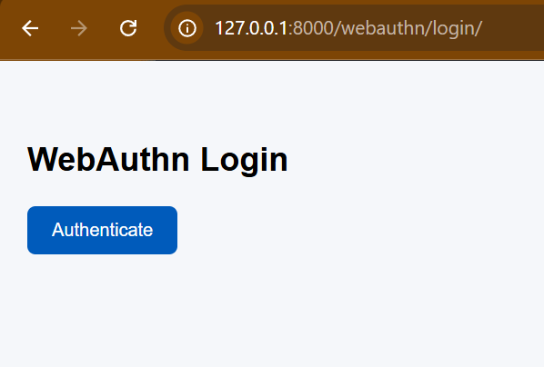
Figure 15—WebAuthn authentication screen
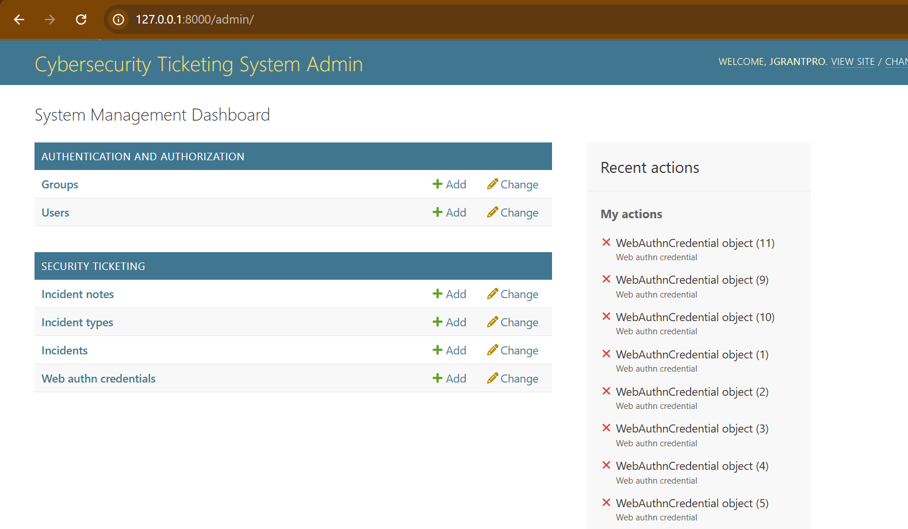
Figure 16—Successful WebAuthn login
If the website is not the original domain, the key will refuse to sign the challenge and reject authentication.
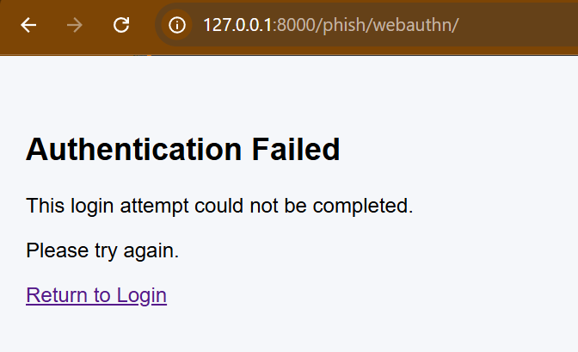
Figure 17—Fake Phishing WebAuthn screen failing due to origin binding
Therefore, no credentials were obtained, and the account is completely safe from phishing attempts, as authentication will be rejected without any credentials to steal.

4.2 Initial Trials
Time Before Attack | Approximate Success Rate (OTP) | Approximate Success Rate (HOTP) | Approximate Success Rate (Webauthn)
0 Seconds (instant) | 100% | 100% | 0%
30 Seconds | ~70% | 70% | 0%
60 Seconds | ~0% (Code expires) | 50% | 0%
Figure 18—First 10 tests for each protocol results
After running the experiment twice over (meaning 20 more attempts for each), the numbers slightly adjusted (some for human error or compounding factors like human frustration) but remained relatively the same.
Time Before Attack | Approximate Success Rate (OTP) | Approximate Success Rate (HOTP) | Approximate Success Rate (Webauthn)
0 Seconds (instant) | ~97% | 97% | 0%
30 Seconds | ~73% | 77% | 0%
60 Seconds | ~0% (Code expires) | 53% | 0%
Figure 19—30 Trials for each protocol results
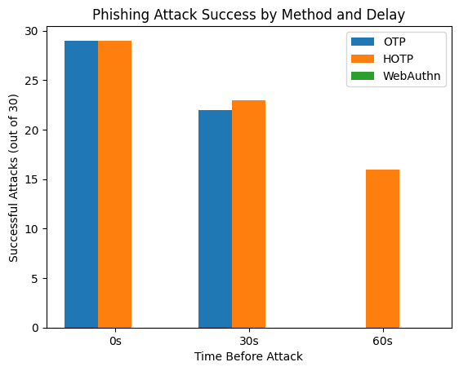
Figure 20—Bar graph results

Results/Discussion

5.1 Experiment Findings
Through testing, I was able to evaluate the performance of each passwordless authentication protocol when subjected to phishing attacks. Multiple attempts were conducted, with varying delays between credential capture and attacker use (immediate, 30 seconds, and 60 seconds). This allowed for a clear comparison of how each protocol performs over time and how sensitive each method is to delay.
The SMS OTP attacks showed nearly perfect success when performed immediately, a high success rate after 30 seconds, and no success after 60 seconds due to code expiration. HOTP produced similarly high success rates for immediate and 30-second attacks. However, unlike SMS OTP, many attacks remained successful even after 60 seconds. This difference can be attributed to the fact that SMS OTP codes expire within a fixed time window, whereas HOTP codes remain valid until a new code is generated, giving attackers a longer and less predictable window to use the captured code.
In contrast, no successful phishing attacks were recorded against WebAuthn. This is due to the nature of WebAuthn, which does not transmit credentials that can be intercepted. Instead, authentication is performed through a challenge-response process in which the legitimate website issues a challenge that is signed by the user’s device using a private key that never leaves the device. If the signature matches, authentication is granted; if it does not, access is denied. Additionally, if the challenge originates from an unrecognized or malicious domain, the device will refuse to sign it. This ensures that phishing websites cannot obtain usable authentication data or successfully impersonate the user.

5.2 Result Interpretations
The results indicate that WebAuthn provides significantly stronger security compared to SMS-based OTP and HOTP. Unlike these methods, the success of phishing attacks against WebAuthn does not depend on timing or attacker speed. This is due to its use of origin-bound asymmetric cryptography, where authentication is tied to the legitimate domain and requires a private key that remains securely on the user’s device. Because no reusable credentials or one-time codes are transmitted or manually entered, attackers are unable to intercept or replay authentication data. Additionally, WebAuthn inherently satisfies multi-factor authentication requirements through the combination of device possession and cryptographic verification, making it highly resistant to adversary-in-the-middle phishing attacks.

5.3 Limitations
While the experiment provided a practical evaluation of each authentication protocol, several limitations should be acknowledged, as addressing them would improve the accuracy and generalizability of the findings.
First, the sample size was relatively small. Each protocol was tested for phishing resistance only 30 times, which is not representative of the scale at which phishing attacks occur in real-world environments. Increasing the number of trials would yield more reliable data and allow for more precise estimates of each protocol’s resilience.
Second, the experimental environment lacked complexity. All tests were conducted on the same web application, with only the authentication method varying. This controlled setup does not account for real-world variables such as system misconfigurations, user behavior, or vulnerabilities like poor input validation. In practice, these factors can significantly influence the success rate of phishing attacks, meaning the experiment does not fully capture the diversity of real-world scenarios.
Finally, no demographic data was considered. Factors such as age or geographic location may influence susceptibility to phishing attacks. Because this information was not collected or analyzed, no conclusions can be drawn about how different user groups may be affected.

Conclusion
SMS OTP and HOTP both failed when it comes to phishing security. This is because they are credential-reliant authentication methods that do not verify that the sender or website is legitimate, meaning they can be entered on a fake website and easily captured and used by an attacker. With SMS OTP, it offered time-based protection since the codes expired in about 60 seconds. This puts the attacker’s window on a timer, but with the prevalence of proxies, it is not difficult for an attacker to implement a script that immediately uses the stolen credentials. HOTP only generates a new code when requested, meaning there is no fixed timer on the attack, and it is instead limited by user behavior. This can come from user frustration or suspicion during the process. As a result, the longer an attacker takes, the less successful the attack tends to be, with the most effective attacks being nearly instantaneous.
The data suggests that WebAuthn is highly resistant to phishing attacks due to its origin binding. This means that no matter what an attacker does, a fake site cannot successfully authenticate the user because the domain will not match what the user’s device expects. Because of this, WebAuthn is widely recognized as a highly secure authentication protocol. However, it is not without drawbacks. Its reliance on a physical device means that losing the device or having the private key wiped (such as during a reset) can result in the user losing access to their account. This highlights the importance of strong account recovery mechanisms provided by the service.
Due to the research and experimental data, it can be reasonably concluded that WebAuthn is more secure against phishing and man-in-the-middle attacks than SMS OTP or HOTP. This is due to WebAuthn’s origin binding, which ensures that both the user’s device and the website are legitimate before authentication is completed. There are also no transferable credentials involved: the user’s private key never leaves the device and is only used to sign a challenge from the legitimate website. Any fake website will present a challenge tied to a different domain, which the user’s device will not recognize, and therefore it will refuse to sign or authenticate. As a result, phishing sites are unable to capture usable credentials, and the authentication attempt fails entirely. This provides a high level of resistance against phishing attacks.
SMS OTP and HOTP both struggle for similar reasons, but the data suggests that SMS OTP is slightly more secure than HOTP in phishing scenarios. The core issue is that both rely on user-transferred credentials, meaning attackers can trick users into entering their login information and one-time codes into a fake website. These codes can then be used by the attacker in real time to gain access. While SMS OTP is constrained by short expiration times, HOTP does not inherently expire and instead depends on a counter, making the attack window more dependent on user behavior and timing. Although these attacks do not guarantee success, the research shows that they are relatively easy to execute and have a high likelihood of success, meaning both methods should be used with caution in environments vulnerable to phishing.

References
Authenticator and Verifier Requirements. Authenticators. (2025, August 1). https://pages.nist.gov/800-63-4/sp800-63b/authenticators/
Bonneau, J., Herley, C., Van Oorschot, P., & Stajano, F. (2012). The quest to replace passwords: A framework for comparative evaluation of web authentication schemes. IEEE Symposium on Security and Privacy.
CISA. (2022, October). Implementing phishing-resistant MFA. https://www.cisa.gov/sites/default/files/publications/fact-sheet-implementing-phishing-resistant-mfa-508c.pdf
Das, S., Kim, A., Tingle, Z., & Nippert-Eng, C. (2019, August 16). All about phishing: Exploring user research through a systematic literature review. arXiv.org. https://arxiv.org/abs/1908.05897
FIDO Alliance. (2019). FIDO2: Moving the world beyond passwords.
Modernize federal identities. IDManagement. (2024, February 22). https://www.idmanagement.gov/playbooks/altauthn/
Multi-factor authentication: A survey. Cryptography, 2(1).
Ometov, A., Bezzateev, S., Mäkitalo, N., Andreev, S., Mikkonen, T., & Koucheryavy, Y. (2018).
Thomas, K., Li, F., & Zand, A. (2020). Data breaches and phishing attacks: The role of
adversary-in-the-middle frameworks in credential theft. Proceedings of the ACM Internet Measurement Conference.

